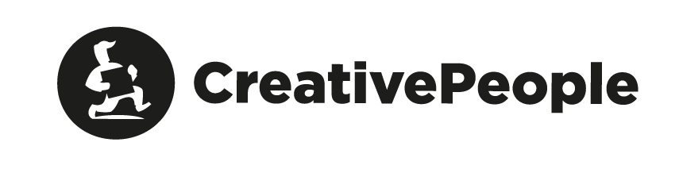
BRIEF.
Website development

Please, fill in this form with as much detail as possible for better definition of website goals. This will help us to get more precise project overview and quickly determine the price and implementation deadlines.
In case any questions of the brief seem complicated, please, refer to us for clarifications. We ensure absolute confidentiality of the provided information about you and your business.

General Information
Date:
Company name:
Domain name of the website:
Contact information
- Full name of a contact person:
- Position:
- E-mail:
- Business/cell phone numbers:
Please, specify the address of your company's office where we can hold working meetings on the project:
Are you ready to come to our office for working meetings? (Moscow, Bolshoi Kazenny Lane, ½, b. 1)?
How did you learn about CreativePeople:

About product/brand/service
What does your company do? List some of its distinctive features.
Describe the brand/product/service:
Specify geographical spread of the brand/product/service:
Enumerate unique advantages of the brand/product/service:

Task assignment
What needs to be done?
What is the task for the agency?
What are the project’s marketing goals?
What are qualitative and quantitative criteria of a successfully released project?
In case a website already exists, describe the problems to be solved.
Describe your website's target audience in groups, specify characteristic features of the website’s visitors, place the target groups in priority order:
Enumerate your direct and indirect competitors, include their websites if possible:
Evaluate their websites (and their work on the Internet in general), note positive and negative sides.
Name the most successful example of positioning on the Internet among your competitors:
Indicate the planned period of the project's realisation:
- Selection of contractor
- Work commencement
- Publication of the website
What is the expected budget of the project?

Structure and content of the project
Website's structure. Enumerate the primary points of the menu:
Describe key functional possibilities of the website (calculators, application forms, subscriptions, etc.):
Evaluate information renewal rate if possible
(each website section separately):
What language versions of the website are expected?
Who creates content for the website?
Evaluate current percentage of the content readiness:
Do you need the content to be created?
- Is photoshoot needed?
- Do you need help with text editing?
- What texts need to be written from scratch?
What are technical limitations for website development:
- Expected web traffic:
- CMS:
- ANYTHING ELSE:
Is organization of the integration with other websites or software required (CRM, ERP, intranet, etc.)?
Specify them:
Do you need a responsive design or a separate mobile version?

Website support
By what means is an existing website maintained? Do you maintain it yourself/inside the company or with the help of a contractor?
Do you have a specialist who will manage your website's maintenance?
Do you need future support and development from the web-developer (back-end, front-end, other?)

Analysis of visual style
Does your company have a logo and visual identity (brand book)?
Attach it to this brief or provide link to it.
Are you interested in development of a new logo/visual identity or redesign of the existing ones?
List several websites you like (regardless of their subject matter).
Specify what exactly attracts you?
List several websites you dislike (regardless of their subject matter).
Specify what exactly discourages you?
Describe your future website with several adjectives (for example, modern, convenient).
List at least 5 attributes:
Also specify what your website shouldn't be like (for example, bright, posh).
List at least 5 attributes:
If your website was a character, who would it be?
Describe gender, age, status, passions and interests:

Website promotion
Do you have strategy of your brand's/product's/service's promotion?
Who in your company is responsible for realization of this strategy?
In what way is website integrated into this strategy?
Do you need the interaction of a website and other advertising media?
(outdoor advertising, promotional activities, printed mass media, other websites, etc.)?
Do you need website’s promotion in future?
By which means and by whom?
Is it necessary to prepare a promotion offer? (SEO, context, SMM)?
Do you have official pages in social media?
List the links to your social media profiles:
Who is responsible for SMM?

Specifications
Please, specify everything that in your opinion can make the task of website development more precise.
Please, enclose additional materials if necessary.

